**Oasis 2nd Grade Supply List 2020-2021**

As we start the year with virtual learning your student will need the follow materials at home to be successful.

**Items to be used at home while using Florida Virtual**

many of these will also be used once we go back to in person learning.

1 personal headsets (over the ears) – NO EAR BUDS (must be replaced if they break

3 ring binder to be used as an interactive notebook for all subjects

Pencils and erasers

scissors

1 box of crayons

1 package of 10 classic markers

1 package of colored pencils

12 glue sticks (extras will be brought to school once we go back to in person)

ruler

wide ruled paper-1 package

printer paper

multi-colored paper

dice

**Items to be used once we are back on campus**

1 backpack

1 personal headsets (over the ears) – **NO EAR BUDS** (must be replaced if they break)

1 **PLASTIC RED** folder **WITH** prongs

1 box of crayons- not larger than a 24-count box

1 package of 10 count markers - thick

4 highlighters-**one** of each color- **pink, green, blue, and yellow**

12 glue sticks

2 small plastic pencil boxes (1 for supplies and 1 for face masks)

6 face masks each in a Ziplock sandwich bag

4 black Dry Erase markers

1 package red pens

24 #2 pencils – **NO Mechanical pencils.** Please consider purchasing **Ticonderoga brand**  pencils as they are higher quality and last longer.

1 package of pencil top erasers

12 glue sticks (NO liquid glue)

1 pair of scissors

**P.H.I.N binder- Personal Homework & Information Notebook**

1 1 in binder (WHITE ONLY) WITH clear outer pocket

5 Tab dividers with pockets

1 **PLASTIC** pocket folder with 3-hole punches –NO PRONGS

1 Pencil pouch to put into binder

**Directions on how to put together are on the back of this page.**

**Please assemble before the first day of school.**



How to Assemble your P.H.I.N. Book

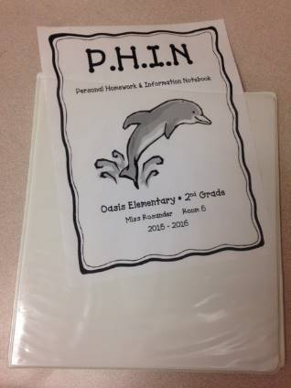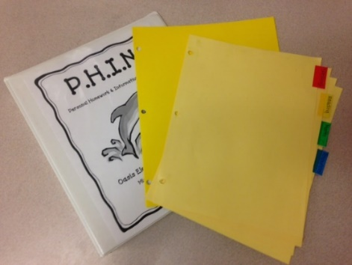 Your binder will need to

have a clear pocket on

the front. Your teacher

will provide the cover page.

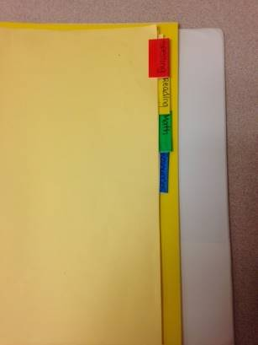Step !: Step 2:

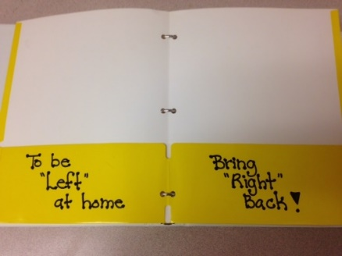

Label the tabs with **Reading, Place the plastic folder in the binder**

**Language Arts, Math, Resources, behind the tabs.** Label the pockets with

**and Data** in that order and place **To Be “LEFT”** at home, label the right

them in the binder. Place the pocket- **Bring “RIGHT” back**

pencil pouch in front of tabs.